Question 7
Generate a separate vertical bar chart for Recency, Frequency, and Monetary groups. Please briefly comment on the charts.

The recency score lines up at 20% for each quintile, this is what we were hoping for – equal distribution of 20% observations.
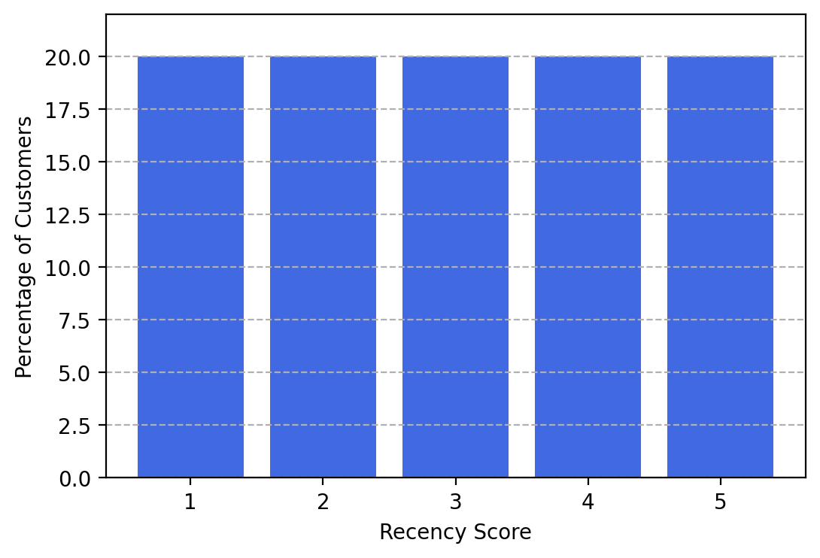

The frequency score does not exactly line up at 20% for few buckets. This is not unusual as we may have a lot of ties in our data and the cutoff might split the data unequally which is true given the values below.
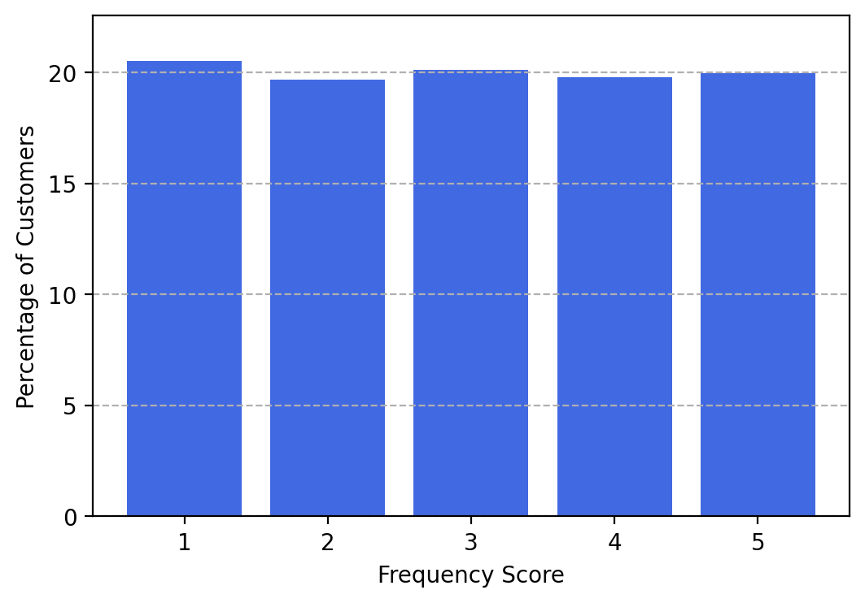

Table #1 Value in each bucket or quintile
- 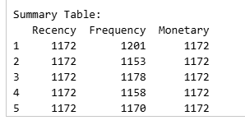

Table #2 Unique Values and Tie values

Lots of ties especially at the cutoff values of quintiles e.g. at 16 – 80 data points
- 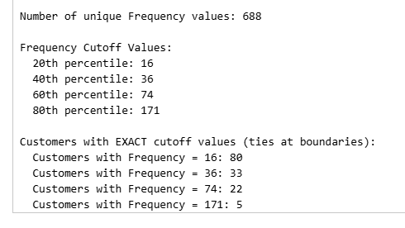

The monetary score lines up at 20% for each quintile, this is what we were hoping for – equal distribution of 20% observations.

